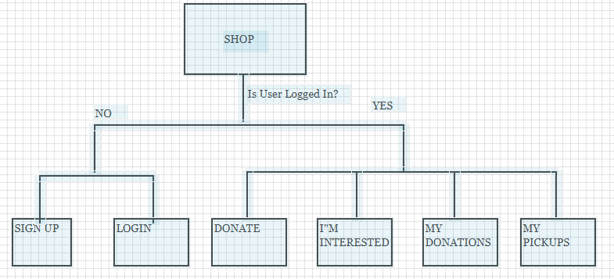

* **Add user profile to YES, user is logged in**

Go through each module

* Document all db data and models
* ~~User data~~
* Validate all user data
* Implement UI messages for user data
* Donations data
* ~~Add require to fields from user model~~
* Identify all the data: states and props
* Identify the flow of data
* Identify all functions and handlers
* Identify all components
* Modify all components to make smaller components
* Add names to component elements that make sense for form input
* Use BootStrap 4 (css and js) , revise application to be mobile responsive.
* Add validation to components
* Modify all components to make functional components and make parent state component
* Add Redux: reducers, actions and store.
* Use Redux to feed stateful components
* Add lifecycle methods to all classes
* Analyze all lifecycle methods
* Add tests to all functions
* Add conditional for file upload if dev or production
* Redo passport and user authentication using local and google.
* Understand every bit of code, comment all code.

# Login & Signup Component

* ~~Implement new modal components for login and signup~~
* ~~Implement bootstrap 4, remove bootstrap 2~~
* Implement mobile responsiveness
* Client-side validation
* Server-side validation
* Add Focus on input when open
* Validate messages
* Validate = false – do not close on login button click
* Rewrite and understand passport auth
* Write and understand google auth

# Navigation Bar

* Add icon to collapse menu
* Mobile responsive

# Search Bar